PRESS RELEASE
No. 129/SP/TKP-ASEAN2023/8/2023
PUBLIC COMMUNICATIONS TEAM

FOR IMMEDIATE RELEASE

President Joko Widodo to Chair Twelve Meetings at the 43rd ASEAN Summit in Jakarta
Jakarta, Kominfo Newsroom – Indonesian President Joko Widodo (Jokowi) will chair twelve meetings during the 43rd ASEAN Summit at Jakarta Convention Center (JCC), Jakarta, on 5 – 7 September 2023.
The Director General for ASEAN Cooperation at the Indonesian Ministry of Foreign Affairs (MoFA) Sidharto R. Suryodipuro conveyed the information during a virtual press conference titled “Road to the 43rd ASEAN Summit” held by the Forum Merdeka Barat 9 (FMB9) in Jakarta, Friday (11 August 2023).
“The president will chair twelve meetings, including the 43rd ASEAN Summit plenary session, the 43rd ASEAN Summit retreat session, the 26th ASEAN-China Summit, and the 24th ASEAN-South Korea Summit,” he said.
According to Sidharto, there is also a plan for the 43rd ASEAN Summit to invite the International Monetary Fund (IMF), the World Bank, and several other international organizations.
The Head of State is also scheduled to lead several non-session events, such as the opening of the 43rd ASEAN Summit, the opening of the ASEAN-Indo-Pacific Forum, a gala dinner, social events, the closing ceremony, and the handover of the ASEAN chairmanship to Laos.
Sidharto also mentioned that both plenary and retreat sessions of the ASEAN Summit will be held on 5 September.
A summit between ASEAN and partner countries will be held on the following day, which will last until 7 September. The East Asia Summit and the ASEAN Plus Three Summit will also take place on 7 September.
Sidharto stated that the upcoming summit will also be an opportunity for various bilateral meetings between the attending leaders.
“However, the expected goals are to strengthen the achievements and foundations of the ASEAN 2045 Vision as well as strengthen the institution of ASEAN to be more effective and efficient in decision-making and substantive organizational matters,” said Sidharto.
Sidharto explained that in its fourth chairmanship, Indonesia is focused on establishing the foundation for future strategic collaboration among ASEAN member states. Indonesia aims to establish a strong and reliable ASEAN institution by overseeing and enhancing its various working mechanisms and resources.
“The other goal is to determine the future agenda of the region, including trade, investment, digitization, and the blue economy as a new source of growth. Naturally, there is also the role of the Indo-Pacific outlook. We need to find a way to manifest all of this in the context of economics and development,” he said.
Previously, the 42nd ASEAN Summit on 10 – 11 May 2023 in Labuan Bajo, East Nusa Tenggara (NTT) Province had produced several outcomes.
One of them was matters that affect the interests of the people, which are of vital concern to the leaders, including the protection of migrant workers and victims of trafficking in persons. The Head of State also invited ASEAN countries to take firm actions against the main perpetrators of trafficking in persons.
In relation to Myanmar, ASEAN countries agreed that the violation of humanitarian values cannot be tolerated. Moreover, “the Five-Point Consensus” mandates ASEAN to engage with all stakeholders in Myanmar.
“ASEAN must strongly uphold inclusivity because the credibility of ASEAN is at stake,” said Sidharto.
Indonesia is open to engaging in communication with anyone in the context of humanitarian interests. However, engaging does not mean giving recognition, as ASEAN unity is paramount to prevent other parties from dividing ASEAN.
The last outcome was the strengthening of economic cooperation. ASEAN countries agreed to build an electric car ecosystem and become an important part of the world supply chain, thereby making the downstream industry a key focus. In addition, ASEAN countries agreed to strengthen the implementation of local currency transactions and digital payment connectivity between countries. (Eko/US/TR/WW)

***
For more information, please contact:
Director General of Public Information and Communications of the Ministry of Communications and Informatics – Usman Kansong (0816785320).
Get more information at http://infopublik.id.
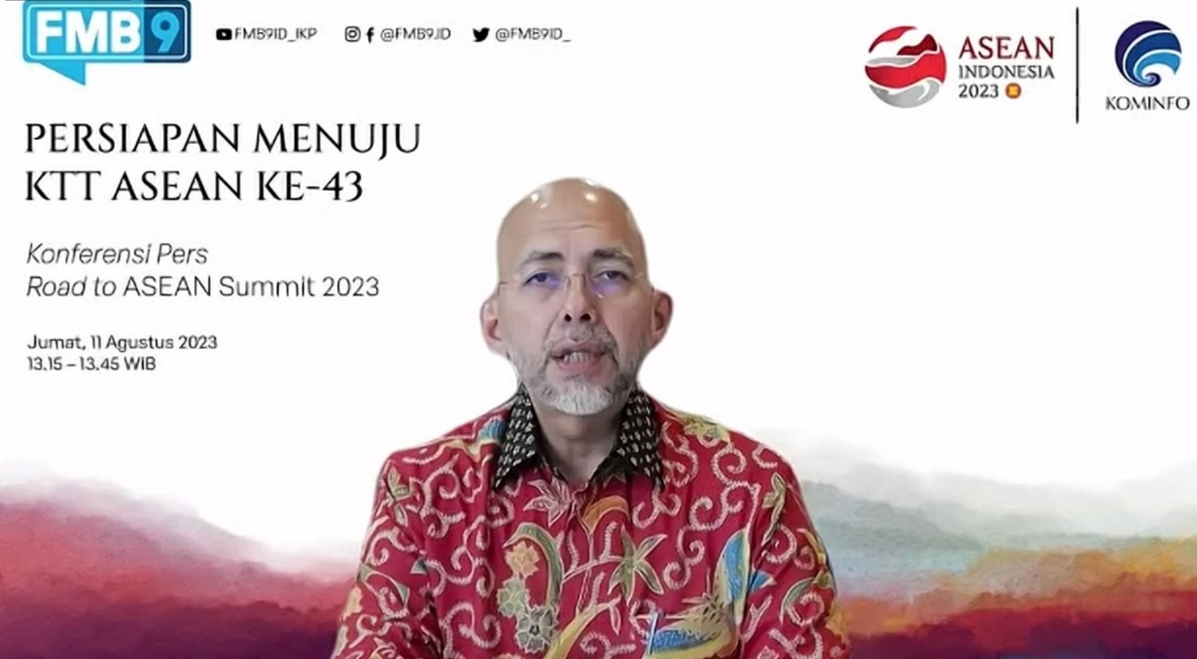
Director General for ASEAN Cooperation of the Ministry of Foreign Affairs Sidharto R. Suryodipuro gives a statement during a virtual press conference titled “Road to the 43rd ASEAN Summit” held by the Forum Merdeka Barat 9 (FMB9) in Jakarta, Friday (11 August 2023). (FMB 9)

